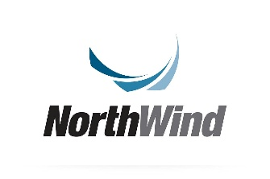
Exploratory Data Analysis (EDA) Project
Northwind

Overview

Project Background
This project is an Exploratory Data Analysis for the Company Northwind.
The project’s main goal is to analyze Northwind’s digital store to generate insights that could help the company improve its profitability.

About Northwind: Conceptual Overview

Company Profile
Northwind is a wholesale distributor that supplies a range of products primarily within the food and beverage categories, that specializes in the importation and exportation of different food products from around the world.

Core Operations of the Company

Product Sourcing and Pricing:

Northwind sources products through various suppliers. Each supplier provides specific product categories, such as beverages, produce, or packaged items.

“UnitPrice” fields in the "Products" table and the "Order Details" table denote the buying and selling prices, respectively. Northwind buys products at wholesale prices from suppliers and sells them at marked-up prices to customers, aiming to generate profit through this margin.

Inventory Management:

Inventory is implied in the "Products" table, with fields such as “UnitsInStock” and “UnitsOnOrder”, which help Northwind track current stock levels and items awaiting restocking.

Customer Relationships:

Northwind serves a variety of business customers, and tracks and manages orders for each customer.

Customer relationships are reflected in ordering data, showing who is ordering, how frequently, and the specifics of each order.

Order Fulfillment:

Northwind's Orders and Order Details tables document each sale, including order dates, shipping details, and employee assignments. These tables support the entire order process, from initial order placement to shipping and delivery.

Profit Generation

Northwind’s profit generation approach is built on buying products at wholesale prices and selling them at higher prices to customers.

Revenue is generated when orders are placed and fulfilled. The selling price is typically higher than the buying cost, creating a margin that represents gross profit.

Because Northwind is a wholesale distributor, it likely focuses on selling in bulk, leveraging high volumes to drive revenue.

Research Motivation
Northwind’s mission is to provide quality products efficiently and to build strong relationships with its clients, ensuring they receive what they need when they need it. Moreover, Northwind Business Idea is to gain revenue through gross profit leveraging high volumes to drive revenue.
Therefore, this EDA is set on 5 Key performance indicators:
      - Repeat Purchase Rate (Product Quality, customer relationships) - In the absence of direct satisfaction surveys, product quality and customer relationship strength are inferred from repeat purchasing behavior and revenue stability.
      - OTIF - On-Time & In-Full Delivery (Efficiency) – the company’s ability to fulfill customers’ orders reliably without delays or shortages deflect first and foremost it’s efficiency.
      - Customer Concentration Ratio (Customer relationships, High Volumes) – By identifying which customers are the most profitable and active the company can optimize its customer relations efforts.
      - Gross Profit – Northwind’s business plan, as a wholesale company, is built around the concept of gross profit, analyzing profit sources and leading cost factors will generate crucial insights for the company’s growth.
      - AOV – Average Order Value (High Volumes)- The conclusions that will be drawn from studying order’s volume trends and their factors will focalize the company’s efforts on increasing order volumes.
For each metric, the following analysis will be conducted:
- Analyze the company’s operations, identifying trends, outliers, patterns, and relationships between variables
- Detect anomalies, missing values, or potential data quality issues
- Generate insights which will aid Northwind’s board decision-making in aim to increase the company’s profit and fulfill key metrics.

Research Question
The analysis is guided by the following primary research question:
- Main Research Question:
"How can Northwind increase its profit using data-driven decisions?".
Additional sub-questions explored include:
- What are Northwind most popular products? Are there any products that have low repeat purchase rate?
- Where can the company optimize its operations in order to increase efficiency? Where are most of the company’s customers located?
- Who are Northwind’s most active and profitable customers? What are their profiles? How can we improve the company’s relationship with those customers?
- How can Northwind increase its gross profit? What are the profitable products? Are there any costly products? Is the company losing on certain products?
- What affects AOV? Order’s item content, the affection of seasonality

Dataset

Data Source
- Source: Analiza.AnalizaDB.Northwind

Data Structure
- ERD
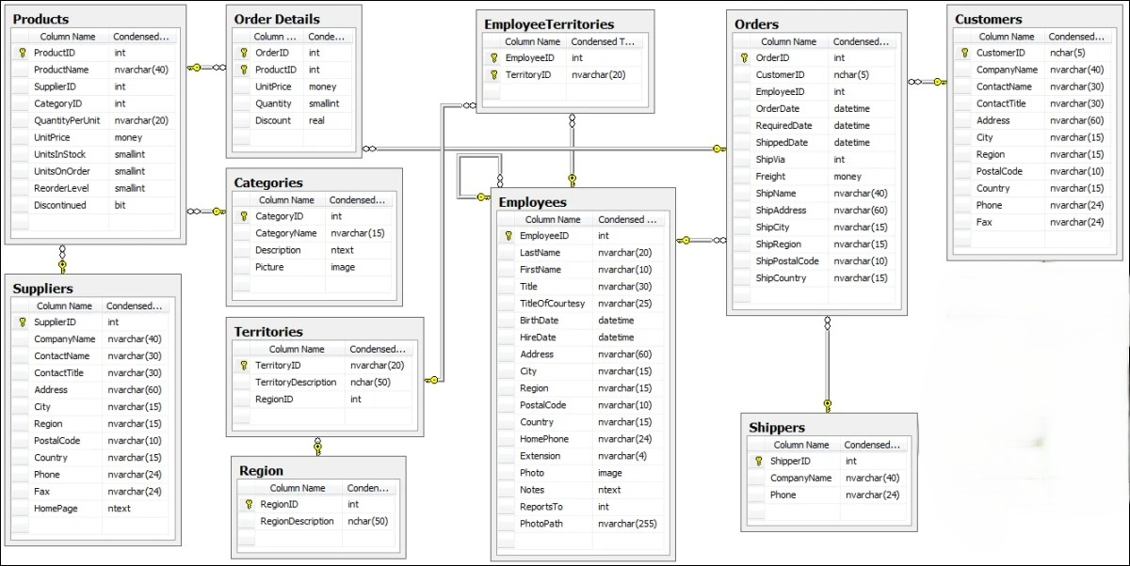

Dataset Description
- Multi-label dataset containing 11 different and related dataset describing different aspects of Northwind operations.

  - Products
Purpose: A dataset holding information about each product the company is selling. Additionally, the company’s product stock is detailed in this dataset.
Size: 10 features * 77 observations
Primary Keys: ProductID (*), CategoryID (FK), SupplierID (FK).
Data Types: int, nvarchar, smallint, money, bit.

  - Suppliers
Purpose: A dataset containing contact information of the different suppliers that are working with Northwind.
Size: 12 features * 29 observations.
Primary Keys: SupplierID (*).
Data Types: int, nvarchar, ntext.

  - Order Details
Purpose: Holding information about the items that make up every order that was made.
Size: 5 features * 2155 observations.
Primary Keys: OrderID (FK), ProductID (FK).
Data Types: int, money, smallint, real.

  - Categories
Purpose: Holding a description of each product category and it’s image.
Size: 4 features * 8 observations.
Primary Keys: CategoryID (*).
Data Types: int, nvarchar, ntext ,image.

  - Territories
Purpose: Detailing each territory name and region.
Size: 3 features * 53 observations.
Primary Keys: TerritoryID(*), Region(FK) .
Data Types: nvarchar, nchar,int

  - Region
Purpose: Detailing each region.
Size: 2 features * 4 observations.
Primary Keys: RegionID (*).
Data Types: int,nchar(50)

  - Employee Territories
Purpose: Connecting employees to their working territories.
Size: 2 features * 49 observations.
Primary Keys: EmployeeID (FK), TerritoryID (FK)
Data Types: int, nvarchar.

  - Employees
Purpose: Holding information about each of the company’s employees including contact and general information, time in the company and the company’s hierarchy (through ReportsTo).
Size: 18 features * 9 observations.
Primary Keys: EmployeeID (*).
Data Types: int, nvarchar, datetime, image, ntext.

  - Orders
Purpose: Holding time-related information of each order and shipping destination.
Size: 14 features * 830 observations.
Primary Keys: OrderID (*), CustomerID (FK), EmployeeID (FK), ShipVia (FK) .
Data Types: int, nchar, datetime, money, nvarchar.

  - Shippers
Purpose: holding contact information of each shipping company.
Size: 3 features * 3 observations.
Primary Keys: ShipperID (*) .
Data Types: int, nvarchar.

  - Customers
Purpose: Holding contact information of each customer of the company.
Size: 11 features * 92 observations.
Primary Keys: CustomerID (*),
Data Types: nchar, nvarchar.

Data Cleaning and Preprocessing
Before performing the exploratory analysis, the following preprocessing steps were applied:
- Handling missing or null values:
  - “ShippedDate” column in Orders: By comparing latest reported dates in the dataset to the order date of orders which don't have a shipped date I conclude that those orders haven’t been shipped at the time the data was documented. Therefore, I will remove them to continue analysis.
  - “OrderDetails” contains orders that do not appear on Orders- causes nulls when joining both tables- I chose to remove those nulls in order to maintain reliability of the data.
- Correcting data types.
- Treating or removing outliers.
- Renaming or restructuring variables for clarity:
  - Renaming Order Details dataset to remove ‘_’ according to CamelCase format which is already used in the dataset.
  - Renaming UnitPrice column in Products to “UnitCost”.
  - Renaming “Shipvia” column in Orders to “ShipperID”.
  - Adding columns to Orders table: “ShippingTime” – a calculated column to tell how long did the shipping take.
All preprocessing decisions were made to improve data quality while preserving the integrity of the original dataset.

Exploratory Analysis Approach
The EDA was conducted using a combination of descriptive statistics and visualizations, including:
- Summary statistics (mean, median, variance, etc.)
- Distribution analysis of key variables
- Correlation analysis between numerical features (regression)
- Comparisons across categorical groups
- Visualizations such as histograms, box plots, scatter plots, and bar charts
The analysis process was iterative, with insights from early steps informing subsequent exploration.

Key Findings
Some of the main insights derived from the analysis include:
- Finding 1: Low RPR (Repeat Purchase Rate) among company’s products
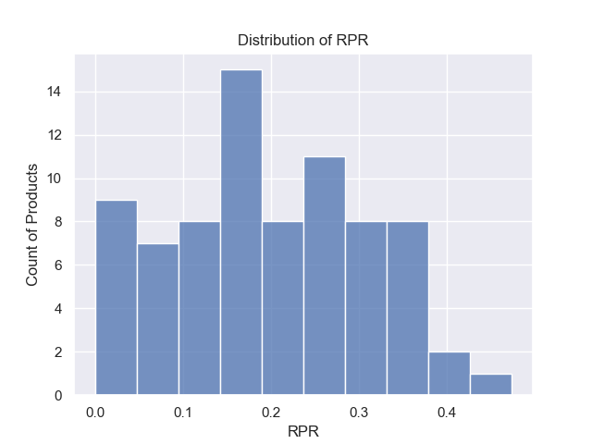
RPR is calculated by the ratio between the number of customers who purchased a product more than once by the number of unique customers who purchased a product.
For wholesales companies, these are the desired rates:
Performance Level | RPR Range
Excellent | 80%-90%
Good/Healthy | 65%-75%
Average | 55%-60%
Low/Concerning | Below 50%
As the graph shows, all of Northwind’s products are located in the low/concerning level of performance.

Moreover, these products have an extremely concerning RPR of 0%:
Product Name | Units In Stock | Discontinued | Number Of Orders Made
Northwoods Cranberry Sauce | 6 | False | 13
Mishi Kobe Niku | 29 | True | 5
Genen Shouyu | 39 | False | 6
Gustaf's Knהckebrצd | 104 | False | 14
Schoggi Schokolade | 49 | False | 9
Gravad lax | 11 | False | 6
Chocolade | 15 | False | 6
Louisiana Hot Spiced Okra | 4 | False | 8
Laughing Lumberjack Lager | 52 | False | 10
Thus, the data points at a crucial weak point of the company. I would recommend a comprehensive audit of customer’s satisfaction by customer relations department and also a quality assessment by quality control team.

- Finding 2: Company’s shipping efforts should be optimized
While Northwind’s OTIF (On Time & In Full) delivery rate stands on a good and competitive rate of 95%, a deeper inquiry should be conducted to ensure an effective and trustworthy customer experience among all of Northwind’s customers.

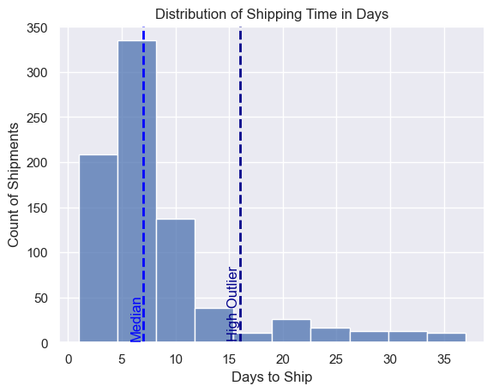
The graph above shows a skewed distribution of shipping time. In order to analyze the 5% of orders that fall out of the OTIF, we should look into the outliers of Northwind’s shipping time distribution (to the right of the graph):
11% of shipments take significantly long time to reach their destination and therefore considered outliers.

2 key features were studied to check for correlation to shipping time: country of destination and the shipper identity.
An ANOVA (Analysis of variance) was conducted and showed no strong correlation.
This means we lack data of other variables related to the company’s shipments.
Although, by creating a heat map we can point out some areas we should focus our research.

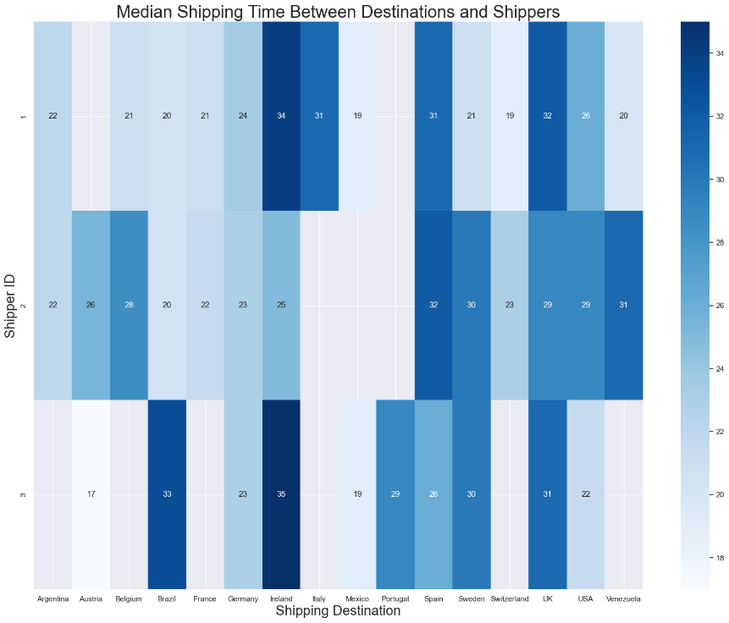
The heat map shows that in several specific countries, shipments took extremely and unacceptable long time among all shippers: Ireland, Spain, UK.
By this analysis I recommend to research shipping operations in those countries.

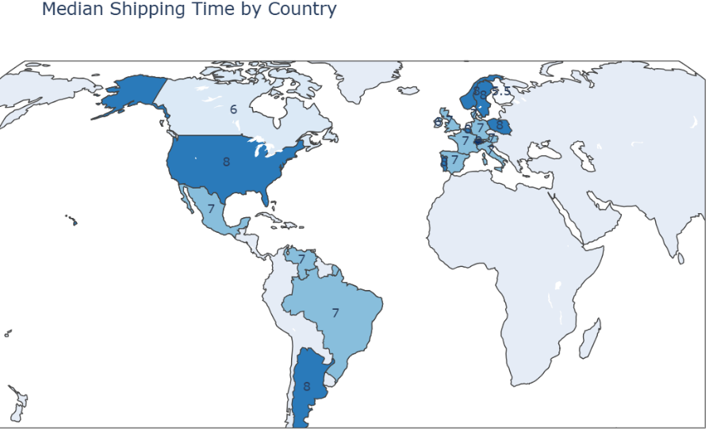
At last, 2 more correlations were checked between the shipping time of all orders: seasonality and shipping destination. The only insight drawn is shown in the next map:

We can see that local shipments (within US) take roughly as much time or even longer than intercontinental shipping.
In order to stay competitive in the local market, among growing competition offering next-day delivery, further research should be conducted and respectively Northwind should allocate resources to improve its local shipping time.

- Finding 3: Northwind’s Diversity of High-Income Customers reached a cautious rate.
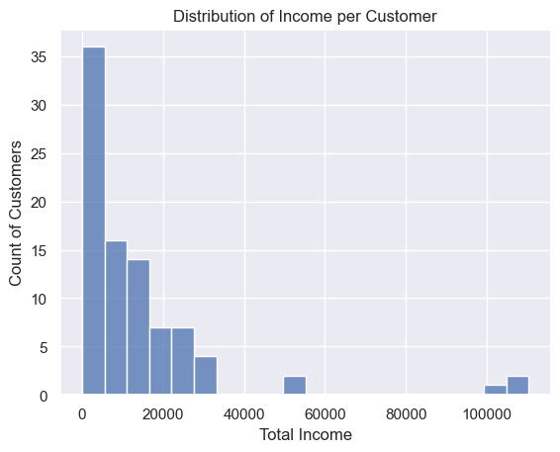
The graph above shows a concerning un-even distribution of income generated by company’s customers. Majority of company’s customers generate low-medium level of income. Derived from it is company’s CCR (Customer Concentration Rate): 25.24%.
The rate was calculated by the income of the 3 leading customers in income (the small bar on the right of the graph):
Company Name | Country | Total Income
Quick-Stop | Germany | 110,277 $
Ernest Handel | Austria | 104,874 $
Save-a-lot Markets | USA | 104,361 $
Two recommendations are derived from the information above:
      - Northwind’s customer relations department should allocate resources to tailor a personalized solution for each of the leading companies.
      - Northwind must expand its number of high-income customers in order to keep a healthy and balanced exposure to risks.

Important information for customer acquisition:
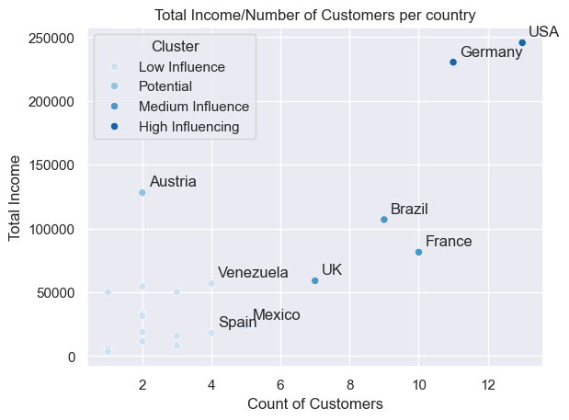
The scatter-plot above shows the scatter of current Northwind customers grouped by country, placed on a grid based on the number of companies from each country and the total income generated from the country.
There are 4 clusters in the graph divided by the influence of the country on the company. Influence is defined by either income generation or high number of companies. According the results, I would point 3 main markets to focus customer acquisition:
  - Austria: location of one Northwind’s biggest customers and equally one of the small countries by customer number. Increasing operations in the Austrian market through highlighting both “Ernest Handel” as a successful partner of Northwind and Northwind’s influence on the German wholesale market could balance the CCR.
  - France/Brazil: Two countries with medium influence on Northwind, already attracting significant amount of company’s attention.

Conclusions
This exploratory analysis provides a comprehensive overview of the dataset and addresses the initial research question. The results demonstrate the value of EDA in uncovering structure, patterns, and potential limitations within the data.
The insights gained from this project can serve as a foundation for further statistical analysis or predictive modeling.

Future Work
Potential next steps include:
- Statistical hypothesis testing:
- Feature engineering and modeling
- Expanding the analysis with additional data sources:
  - Gathering more data about shipping variables (custom delays, local post services delays, weather affect) and expanding the analysis.
  - Increasing data collection on Northwind’s customers- a deeper understanding of the company’s customer’s profile will help focalize Northwind’s efforts towards finding potential customers.
- Applying advanced analytical techniques:
  - Deeper statistical analysis is required in order to properly understand the causes for shipments’ delays.

Tools and Technologies
- Language: Python
- Libraries: pandas, numpy, matplotlib, seaborn, plotly ,statsmodels.
- Environment: Jupyter Notebook, VS Code, SQL, Tableau Public, Excel.
- AI Tools: Gemini - Insperation, Code Guidance. ChatGPT - Proofreading, Text Structure. Gamma - Presentation

